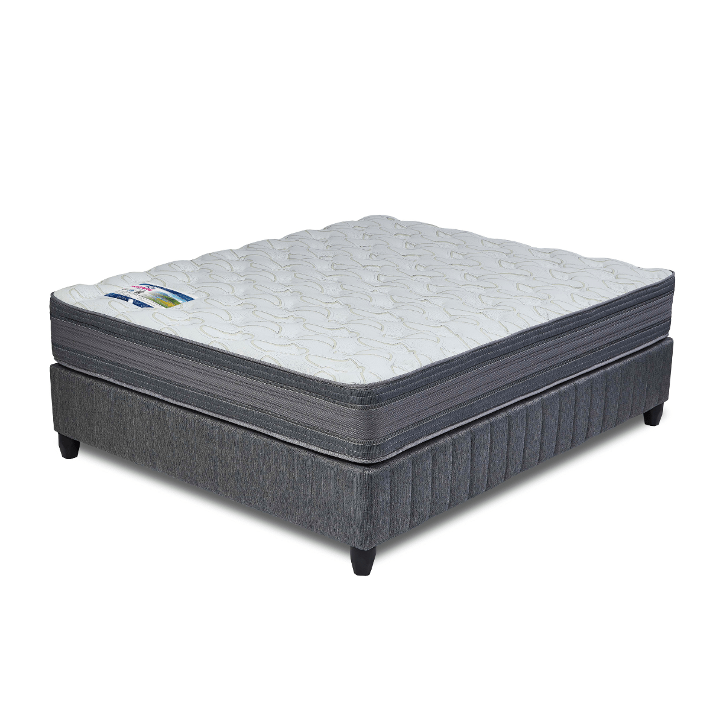


Model : MQ10 Base Set
Supplier/Manufacturer : Rest Assured
Range : Heritage Bonnel Coil Collection
Prices – Bed Set :
- Single Bed Set – R7459
- Three Quarter Bed Set – R8349
- Double Bed Set – R10009
- Queen Bed Set – R10769
- King Bed Set – R13739
Prices – Mattress Only :
- Single Mattress Only – R5799
- Three Quarter Mattress Only – R6519
- Double Mattress Only – R7979
- Queen Mattress Only – R8689
- King Mattress Only – R10429
Prices - Extra Length Bed Set :
- Single Extra Length Bed Set – R8059
- Three Quarter Extra Length Bed Set – R9019
- Double Extra Length Bed Set – R10809
- Queen Extra Length Bed Set – R11629
- King Extra Length Bed Set – R14839
Prices - Extra Length Mattress Only :
- Single Extra Length Mattress Only – R6269
- Three Quarter Extra Length Mattress Only – R7039
- Double Extra Length Mattress Only – R8619
- Queen Extra Length Mattress Only – R9389
- King Extra Length Mattress Only – R11269

*Please use this link for guideline for creating the page* - https://www.bedsonline.co.za/product/rest-assured-mq10-queen/
Rest Assured Link - https://restassured.co.za/our-ranges/heritage/mq10/

